December-Speech and Language Calendar

SUNDAY | MONDAY | TUESDAY | WDNESDAY | THURSDAY | FRIDAY | SATURDAY
2 | 3   | 4   | 5   | 6   | 7   | 8
9 | 10   | 11   | 12   | 13   | 14   | 15
16 | 17   | 18  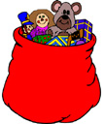 | 19  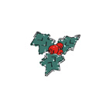 | 20   | 21   | 22
23 | 24   | 25  Merry  Christmas | 26   | 27   | 28   | 29
December-Speech Calendar

Practice your child’s speech sounds while they tell you about each item pictured on the calendar. You can have them try the following activities depending on their level.

*tell a story about the picture

*describe the picture

*make a sentence about the picture

*say a phrase with the word

December—Language Calendar

Have your child name as many attributes about each picture as they can:

Group—what group does this item belong to? See if you can expand beyond “Christmas” group

Do—What do you do with the item? What does the item do?

Looks like: size, shape color

Made of?

Parts?

Where do you find it?

