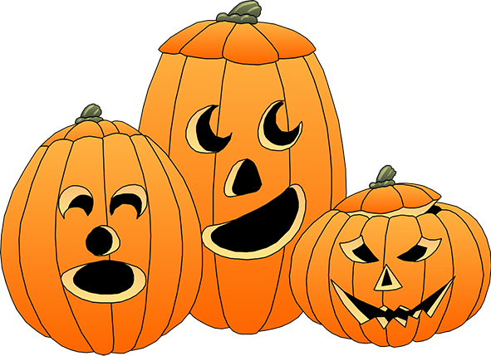October

Language Calendar

|  |  |  |  |  |
| --- | --- | --- | --- | --- |
| ***Monday*** | ***Tuesday*** | ***Wednesday*** | ***Thursday*** | ***Friday*** |
| **Categories** | **Associations(words that go together: shoes:socks)** | **Inferences** | **Homophones/Homographs**  **L1: name difference**  **L2: name differences and use each in a sentence** | **Vocabulary** |
| L1: Name 2 Fall time words  L2: Name 5 Fall time words | L1: witch  L2: autumn | L1: Name 1 clue that we are moving into Fall  L2: Name 4 clues we are moving in to Fall | bat/bat | L1: Fall  L2: Autumn  (define and use in a sentence) |
| L1: Name 2 items that could be used in a costume  L2: Name 5 items that could be used in a costume | L1: jack-o’lantern  L2: cauldron | L1: Name 1 clue it will be Halloween soon  L2: Name 4 clues it will be Halloween soon | witch/which | L1: Name 1 other word for cold (as in temperature)  L2: Name 3 other words for cold (as in temperature) |
| L1: Name 2 things you would see at a haunted house  L2: Name 5 items you would see at a haunted house | L1: spider  L2: cemetery | L1: Name 1 clue there is no one home at the neighbors house  L2: Name 4 clues no one is home at the neighbors house | Fall/fall | L1: festival  L2: cauldron |
| L1: Name 2 Halloween words  L2: Name 5 Halloween words | L1: scarecrow  L2: hayride | L1: Name 1 clue it will be day light savings soon  L2: Name 4 clues it will be day light savings soon | ate/eight | L1: jack-o’lantern  L2: potion |